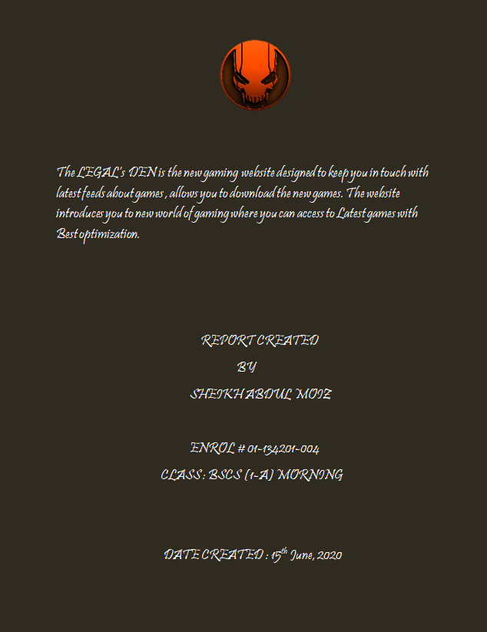

Contents:

Introduction to LEGAL’s Den: 3

Third party websites: 3

Features and functionalities: 4

1) Accessible to All Users: 4

2) Fast Load Times: 4

3) Effective Navigation: 4

4) Good Error Handling 4

5) Contrasting Colour Scheme 4

6) Usable Forms 4

Home page ( CODE and Description): 5

About Us page ( Code and Description): 9

Contact Us page ( Code and Description): 12

Conclusion: 17

# Introduction to LEGAL’s Den:

We are an exciting of Game Developers and Players. We Launched this site on Aug 27, 2011 and want to build huge community for Game Lovers. This website will be platform for those who want to share ideas on games. You can read reviews on latest games.

Those games for which we can provide downloads will be shared as well. We want your full participation in keeping this Gaming community alive. You can **contact us** and share your thoughts. We are excited to hear from you. We’ll post reviews, Game Details, Latest Games Expected Releases etc.

This gaming website have latest news about games and list of top rated games. As this website is still under development so soon this will be a developed and top on the list.

**How we use collected information:**

LEGAL’s DEN may collect and use Users personal information for the following purposes:

*– To improve customer service*  
Information you provide helps us respond to your customer service requests and support needs more efficiently.

*– To personalize user experience*  
We may use information in the aggregate to understand how our Users as a group use the services and resources provided on our Site.

*– To improve our Site*  
We may use feedback you provide to improve our products and services.

**How we protect your information:**

We adopt appropriate data collection, storage and processing practices and security measures to protect against unauthorized access, alteration, disclosure or destruction of your personal information, username, password, transaction information and data stored on our Site.

Our Site is in compliance with PCI vulnerability standards in order to create as secure of an environment as possible for Users.

## Third party websites:

Users may find advertising or other content on our Site that link to the sites and services of our partners, suppliers, advertisers, sponsors, licensors and other third parties. We do not control the content or links that appear on these sites and are not responsible for the practices employed by websites linked to or from our Site. In addition, these sites or services, including their content and links, may be constantly changing. Browsing and interaction on any other website, including websites which have a link to our Site, is subject to that website’s own terms and policies.

# Features and functionalities:

The LEGAL’s gaming Den have vast amount of users fascinating day by day. It provides the list of top rated games of 2020 which has the highest rating among all. You can find the latest game in top rated tab which will be kept updating after span of time. We will promise to provide the best-selling games over the world . We will surely provide new games soon . You can contact us requesting to upload information for any games and to complain about any queries regarding the website which form is available on contact us page.

1. Accessible to All Users:

This website should also be accessible to everyone including blind, disabled or the elderly. These users typically use screen-readers to access the Internet. Every user can access to this site.

1. Fast Load Times:

Nothing is more annoying for website visitors than a website that takes long to load. In fact, slow speed is one of the main reasons why visitors leave a website. Our website loads within 4 to 6 seconds that is important for good usability.

It is also one of the main reasons visitors leave your site. A typical customer will only wait for a few seconds for your page to load, after which they will most likely navigate away to a competitor's site never to visit again.

1. Effective Navigation:

Good navigation is one of the most important aspects of website usability. Simple HTML menus tend to work best and appear consistent on all browsers and platforms.

Good Error Handling

This website is now free of bugs and errors because we have the best technique to avoid the occurring of bugs and errors.

Contrasting Colour Scheme

The right colour scheme has been selected to which created the overlay more beautiful and attractive.

Usable Forms

Forms are a very important element on business websites. A form is created in the contact us page so you can contact us by filling the form

# Home page ( CODE and Description):

1. **HTML CODE:**

<!DOCTYPE html>

<html>

<head>

<title>ABDUL MOIZ 004 </title>

<link rel="stylesheet" type="text/css" href="homepage.css">

</head>

<body>

<header>

<div class="main">

<div class="logo">

<img src="hhh.png" >

</div>

<ul>

<li class="visited" ><a href="#" onclick="location.href='file:///E:/vs/Homepage.html'">Home</a></li>

<li><a href="#" onclick="location.href='file:///E:/vs/top%20rated.html'">Top Rated</a></li>

<li><a href="#" onclick="location.href='file:///E:/vs/Rules.html'"">Rules</a></li>

<li><a href="#" onclick="location.href='file:///E:/vs/about.html'">About</a></li>

<li><a href="#" onclick="location.href='file:///E:/vs/contact.html'">Contact us </a></li>

</ul>

</div>

<div class="title">

<h1 style="font-family:'Courier New'" > LEGAL's DEN </h1>

<p><b> Welcome to the new era of gaming</b><br>

<b> Download new PC games with latest DLC's<br>

Join the LEGAL's community and be a part of the new gaming world</b><br>

<b>All games at one click</b> </p>

</div>

</header>

<footer>

<div class="footer">

<p1 style="font-family:'Courier New'"><b>LEGAl's DEN - Updated Pc Games - &copy;2011-2020 All rights Reserved</b></p1>

</div>

</footer>

</body>

</html>

1. **CSS CODE:**

*

{ margin: 0px;

padding: 0px;

font-family: helvetica ;}

header

{

background-image: url(2.jpg);

height: 880px;

background-size: cover;

background-position: center;

line-height: 100px;

}

header img{

margin-left: 300px;

}

ul{

margin-left: 1150px;

padding-top: 15px;

list-style-type: none;

}

ul li{

display: inline-block;

padding-left: 5px;

}

ul li a{

text-decoration: none;

color: rgb(255, 255, 255);

padding: 5px 15px;

border: 4px solid transparent;

}

ul li a:hover{

background-color: rgb(110, 109, 109);

color: rgb(255, 254, 254);

transition:0.7s;

}

ul li.visited a{

background-color: rgb(110, 109, 109);

color: rgb(255, 255, 255);

}

.logo img

{

float:left;

width:250px;

height:auto;

margin-left: -20px;

}

.title{

position: absolute;

top: 50%;

left:50%;

color:rgba(255, 255, 255, 0.904);

transform: translate(-50%,-50%);

font-size: 70px;

background-color: rgba(100, 1, 1, 0.253);

}

.footer{

background-color: rgba(105, 9, 9, 0.774);

height: 100px;

font-size: 20px;

text-align: center;

padding-top: 24px;

color: white;

}

.title p{

font-size: 30px;

text-align: center;

}

1. DESCRIPTION :

The home page provides the home for the website where you come to know that what the website is about.

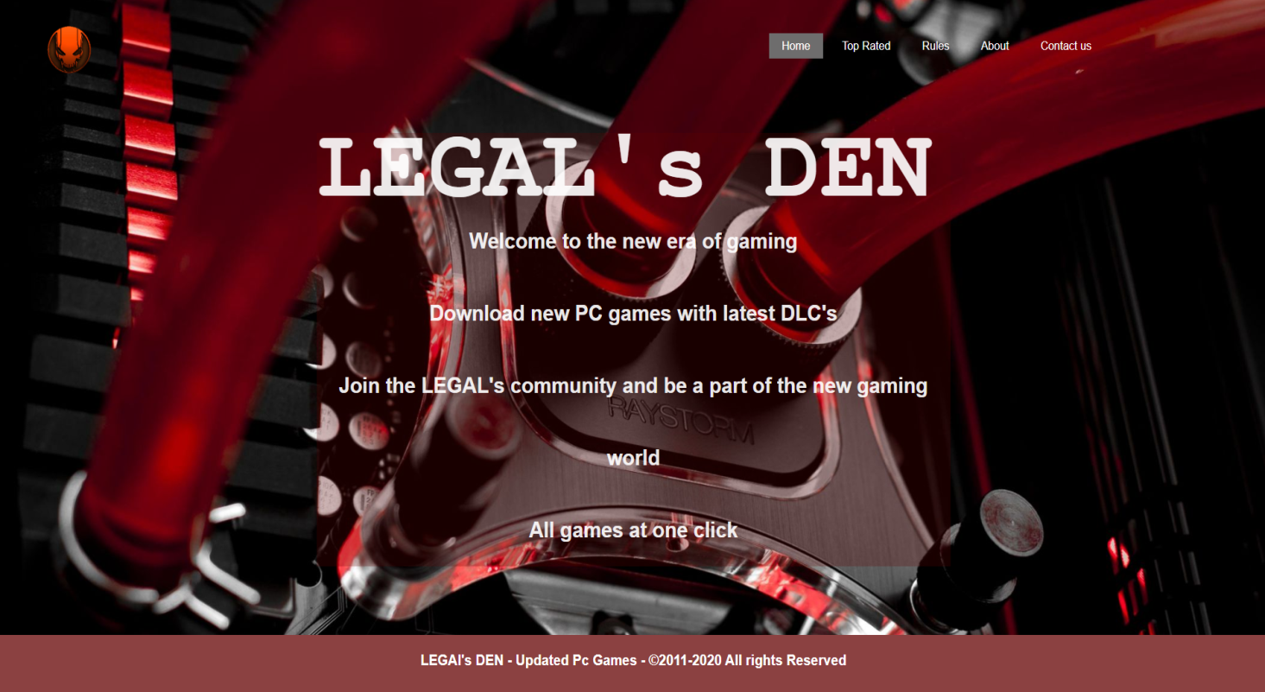I have used external css to quote the styles of several divs. A logo for the website is inserted on top left on the website page. A valid tagline is used for the gaming site. On the buttons a hover is applied with transition which has a beautiful impact on the buttons like home , top rated , about us and contact button. At the end comes a footer.

# About Us page ( Code and Description):

1. **HTML CODE:**

<!DOCTYPE html>

<html>

<head>

<title>ABDUL MOIZ 004 </title>

<link rel="stylesheet" type="text/css" href="about.css">

</head>

<body>

<header>

<div class="main">

<div class="logo">

<img src="hhh.png" >

</div>

<ul>

<li><a href="#" onclick="location.href='file:///E:/vs/Homepage.html'">Home</a></li>

<li><a href="#" onclick="location.href='file:///E:/vs/top%20rated.html'">Top Rated</a></li>

<li><a href="#" onclick="location.href='file:///E:/vs/Rules.html'"">Rules</a></li>

<li class="visited" ><a href="#" onclick="location.href='file:///E:/vs/about.html'">About</a></li>

<li><a href="#" onclick="location.href='file:///E:/vs/contact.html'">Contact us </a></li>

</ul>

</div>

<div class="title">

<h1 style="font-family:'Courier New'" > Who are we? </h1>

<p><b> We repack PC games for fans. We do not crack or violate any copyright

law. We are just normal people just like you who plays games and makes

repack so that users having low BW and speed can also enjoy full game

at small size. You can check our repacks.

If you don't find particular game, feel free to request.</b> </p>

</div>

</header>

<footer>

<div class="footer">

<p1 style="font-family:'Courier New'"><b>LEGAl's DEN - Updated Pc Games - &copy;2011-2020 All rights Reserved</b></p1>

</div>

</footer>

</body>

</html>

1. **CSS CODE:**

*

{ margin: 0px;

padding: 0px;

font-family: helvetica ;}

header

{

background-image: url(about.jpg);

height: 880px;

background-size: cover;

background-position: center;

line-height: 100px;

}

header img{

margin-left: 300px;

}

ul{

margin-left: 1150px;

padding-top: 15px;

list-style-type: none;

}

ul li{

display: inline-block;

padding-left: 5px;

}

ul li a{

text-decoration: none;

color: rgb(255, 255, 255);

padding: 5px 15px;

border: 4px solid transparent;

}

ul li a:hover{

background-color: rgb(110, 109, 109);

color: rgb(255, 255, 255);

transition:0.7s;

}

ul li.visited a{

background-color: rgb(110, 109, 109);

color: rgb(255, 254, 254);

}

.logo img

{

float:left;

width:250px;

height:auto;

margin-left: -20px;

}

.title{

position: absolute;

top: 50%;

left:50%;

color:rgba(255, 255, 255, 0.904);

transform: translate(-50%,-50%);

font-size: 70px;

background-color: rgba(100, 99, 99, 0.253);

}

.footer{

background-color: rgba(58, 58, 58, 0.87);

height: 100px;

font-size: 20px;

text-align: center;

padding-top: 24px;

color: white;

}

.title p{

font-size: 30px;

text-align: center;

}

1. **Description:**

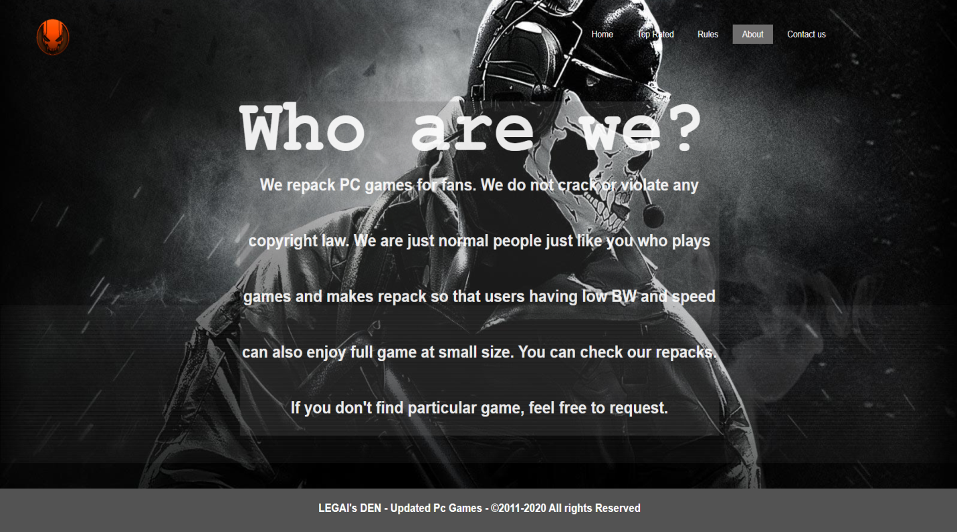About page is made to tell about the website about the features and about us that how this website came into reality. I have used external css to quote the styles of several divs. A logo for the website is inserted on top left on the website page. A valid tagline is used for the gaming site. On the buttons a hover is applied with transition which has a beautiful impact on the buttons like home , top rated , about us and contact button. At the end comes a footer.

# Contact Us page ( Code and Description):

1. **HTML CODE:**

<!DOCTYPE html>

<html>

<head>

<title>ABDUL MOIZ 004 </title>

<link rel="stylesheet" type="text/css" href="contact.css">

</head>

<body>

<header>

<div class="main">

<div class="logo">

<img src="hhh.png" >

</div>

<ul>

<li><a href="#" onclick="location.href='file:///E:/vs/Homepage.html'">Home</a></li>

<li><a href="#" onclick="location.href='file:///E:/vs/top%20rated.html'">Top Rated</a></li>

<li><a href="#" onclick="location.href='file:///E:/vs/Rules.html'"">Rules</a></li>

<li><a href="#" onclick="location.href='file:///E:/vs/about.html'">About</a></li>

<li class="visited"><a href="#" onclick="location.href='file:///E:/vs/contact.html'">Contact us </a></li>

</ul>

</div>

<p class="small"><strong>We do NOT encourage piracy. These links are intended for backup purposes only. Do NOT download the files if you do NOT own the original media.</strong><br />

<strong> All parts of the LEGAL's Den are for private use only. No files are hosted on our server, they are indexed in a similar way to how Google works. The ISP and/or administrator cannot be held responsible for the contents of any linked sites or any link contained in a linked site, or changes/updates to such sites.</strong></p>

<p class="small"><em>Furthermore, we are not a computer help desk and we ignore any emails that do not relate to problems regarding the technical aspects of the site.</em></p>

<p class="small"><strong>Feedback:</strong> If you have any idea or want to share your feedback, feel free to contact us.</p>

<p>Please use the below form to get in touch with us.</p>

<form id="contactform" class="contactform" method="post" action="">

<input type="hidden" id="contact_us_nonce" name="contact_us_once" value="03f09d63f3" /><input type="hidden" name="_wp_http_referer" value="/contact-us/" /> <p class="contact_name" style="color: seashell;">

<input type="text" tabindex="1" size="22" value="" id="contact_name" name="contact[name]" />

<label for="contact_name">

<small>Name (required)</small>

</label>

</p>

<p class="contact_email" style="color: seashell;">

<input type="text" tabindex="2" size="22" value="" id="contact_email" name="contact[email]" />

<label for="contact_email">

<small>Email (required)</small>

</label>

</p>

<p class="contact_phone" style="color: seashell;">

<input type="text" tabindex="3" size="22" value="" id="contact_phone" name="contact[phone]" />

<label for="contact_phone">

<small>Phone</small>

</label>

</p>

<p class="contact_message" style="color: seashell;">

<textarea tabindex="4" rows="10" cols="60" id="contact_message" name="contact[message]">type your message here :</textarea>

</p>

<p class="contact_submit" style="color: seashell;">

<input type="submit" value="Send Message" tabindex="5" id="submit" name="contact[submit]" />

</p>

</form>

</header>

<footer>

<div class="footer">

<p1 style="font-family:'Courier New'"><b>LEGAl's DEN - Updated Pc Games - &copy;2011-2020 All rights Reserved</b></p1>

</div>

</footer>

</body>

</html>

1. **CSS CODE:**

*

{ margin: 0px;

padding: 2px;

font-family: helvetica ;}

header

{

background-image: url(RDR2.jpg);

height: 1200px;

background-size: cover;

background-position: center;

line-height: 100px;

}

header img{

margin-left: 300px;

}

ul{

margin-left: 1150px;

padding-top: 15px;

list-style-type: none;

}

ul li{

display: inline-block;

padding-left: 5px;

}

ul li a{

text-decoration: none;

color: rgb(255, 255, 255);

padding: 5px 15px;

border: 4px solid transparent;

}

ul li a:hover{

background-color: rgb(110, 109, 109);

color: rgb(255, 254, 254);

transition:0.7s;

}

ul li.visited a{

background-color: rgb(110, 109, 109);

color: rgb(255, 254, 254);

}

.logo img

{

float:left;

width:250px;

height:auto;

margin-left: -20px;

}

.footer{

background-color: rgba(114, 62, 3, 0.774);

height: 60px;

font-size: 20px;

text-align: center;

padding-top: 30px;

color: white;

}

p.small{

line-height: 1.5;

color: rgb(255, 253, 253);

}

.p{

color: white;

}

3)Description:

Contact us page is used to help the customer to contact us .A form is created which has to be filled in order to contact us. I have used external css to quote the styles of several divs. A logo for the website is inserted on top left on the website page. A valid tagline is used for the gaming site. On the buttons a hover is applied with transition which has a beautiful impact on the buttons like home , top rated , about us and contact button. At the end comes a footer.

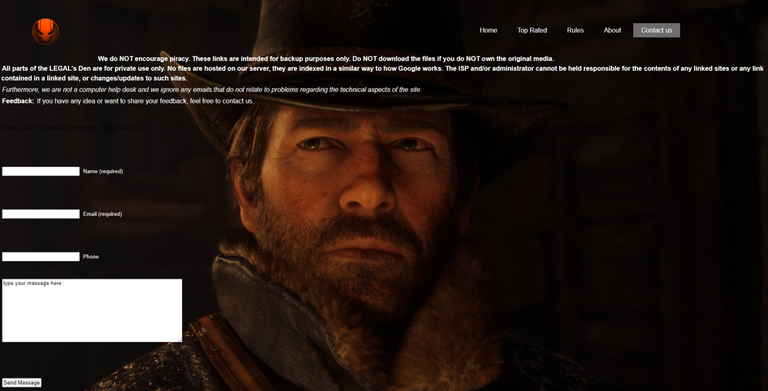

# Conclusion:

This website concludes the passion of players for gaming .It is an open website for all players in the world who can visit it and access the features of the website . It provides you the basic elements to acknowledge the gaming in deep .Somehow it provides you the latest DLC’s pack and updates for the games . If you want a suggestion for a game to be played then surely LEGAL’s Den is the best side you can ever visit and you won’t regret“ **GAMING IS NOT A CRIME “.**

**____________________________________________________________________________**